Objectives Unit 1 – Intro to Science

Chap 1. 1 “The Nature of Science”
- What is Science?
  - Answering “Why, How, What…”
- How is Science different from Technology / Engineering?
- Why is the scientist’s definition of a Theory different from the everyday definition?
- What’s a Model?
  - Physical
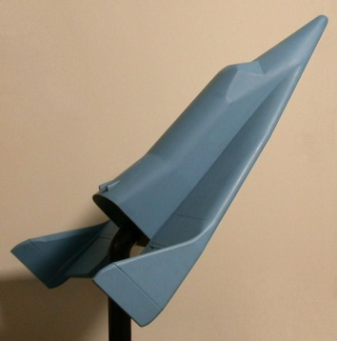
  - Computer/Mathematical
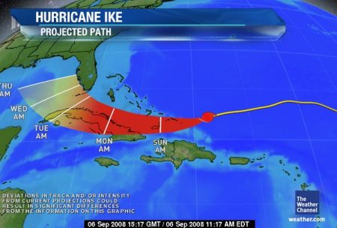
  - Conceptual
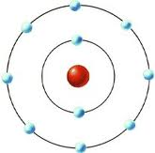

Chap 1.2: The Way Science Works
- What is the Scientific Method, its steps, and why is it used?
- What are the components of a Controlled Experiment?
- Be able to identify the variables in a given experimental description.
- Be able to design a simple experiment to answer a question.
- What are Variables?
  - Independent
  - Dependent
  - Control
Additional Topics Not in the Text
- What is the difference between qualitative and quantitative?
- What are the 4 common misconceptions that people have with science?
  - See Dyer PP
- What are the common types of science and what do they study?
  - See online activity
- What are the parts of a Scientific Study, and what do each include?

