Names:____________________________________________________________
Hour:___________________

Graph That Motion Activity

http://www.physicsclassroom.com/shwave/

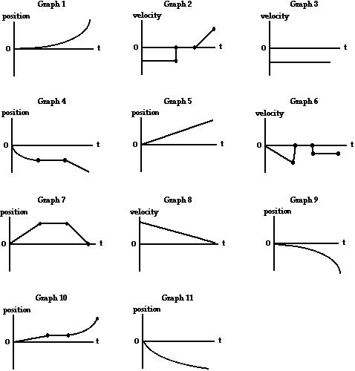

A | B | C | D | E | F | G | H | I | J | K

