Names:______________________________________
Hour:___________________

Go to http://www.physicsclassroom.com/shwave/ and click on the animation link below Name that Motion Activity

Name That Motion Activity

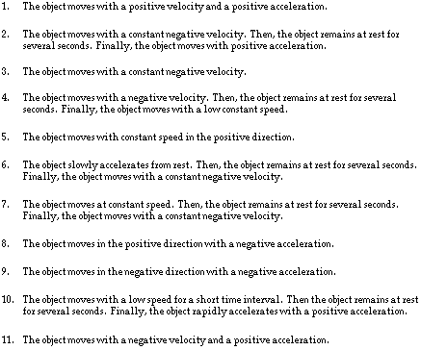

A | B | C | D | E | F | G | H | I | J | K

