Objectives Unit 2 – Data Analysis and Measurement

1.3 Organizing Data
- Which type of graph is used for different situations?
  - Line (of best fit)
  - Bar
  - Pie
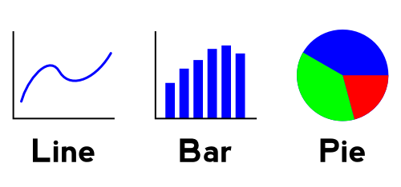
- How do you extrapolate and interpolate with a line graph?
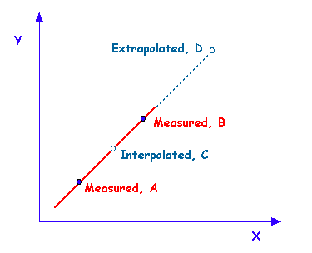
- How do you show relationships with graphs/data, and how can data be presented so it is misleading?
  - Tare Marks
  - Scale of x and y axis

- What is Scientific Notation, Why is it used, and how do you calculated with it?
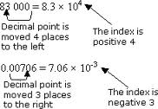

- What is the difference between precision and accuracy, and how does precision determine the Significant Figures?

- How do you determine the number of Sig Figs from the measuring device or in an equation?

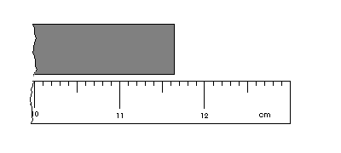
- What are SI Base units, the SI Prefixes, how do you convert SI to SI and SI to English using Dimensional Analysis and the Ladder Method?

