Objectives Unit 3 – Motion

Chap 11.1 “Measuring Motion”
- Why is it important to have a Frame of Reference or a Reference Point when determining the motion of an object?
- What is the difference between Distance and Displacement?
- What is the difference between Speed and Velocity and how do you calculate it?
$$v= \frac{d}{t}$$
- How can you determine velocity from a d vs t graph?
Chap 11.2 “Acceleration”
- What is Acceleration and how do you calculate it?
$a= \frac{∆v}{t}$ or $a=\frac{v_{f}- v_{i}}{t}$
- Why does a change in direction mean there is acceleration?
- How can you determine the acceleration of an object from a v vs t graph?

Chap 11.3 “Motion and Force”
- What is a Force and what does it have to do with mass and acceleration?
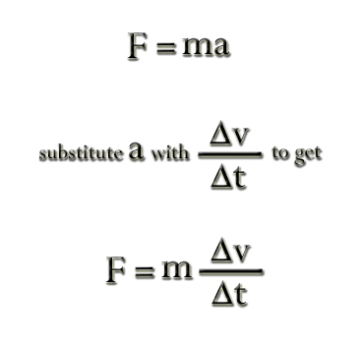
- What are the Fundamental Forces of Nature?
  - Gravity
  - Electromagnetic
  - Strong Nuclear Force
  - Weak Nuclear Force
- What is the difference between Contact Forces and Field Forces?
- What is Net Force?
- What can you determine about the motion of an object by knowing the Net Force acting on it?
- What is Friction and what are the different types?
  - Static Friction
  - Kinetic Friction
    - Sliding Friction
    - Rolling Friction
- What causes friction and what can be done to reduce it?

