Objectives Unit 4 – Forces

Chap 12.1 “Newton’s First and Second Laws”
- What is a Force Diagram and how does it help you determine the motion and/or Net Force acting on an object?
- What is Newton’s First Law?
- Why do objects on earth seem to break Newton’s First Law and come to a stop even if it appears no outside forces have acted upon it?
- What is Inertia, and why is Newton’s First Law often called the Law of Inertia?
- What is Newton’s Second Law and how do you calculate with it?
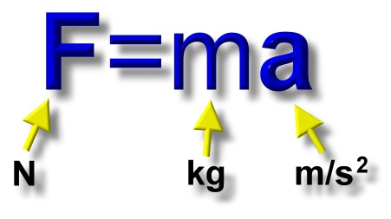
Chap 12.2 “Gravity”
- What is the difference between Weight and Mass?
- What is the equation for Weight and how do you calculate with it?
- What is the Acceleration due to Gravity on Earth?

- What is the Law of Universal Gravitation and what does it tell you about the gravitational force between two objects?
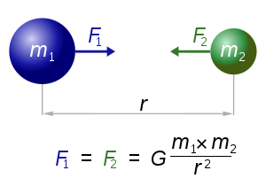
- What is Free Fall?
- What is Terminal Velocity?
- What is Projectile Motion?
Chap 12.3 “Newton’s Third Law”
- What is Newton’s Third Law?
- Why, if there are equal and opposite forces on interacting objects, do they not have equal effects on the objects?
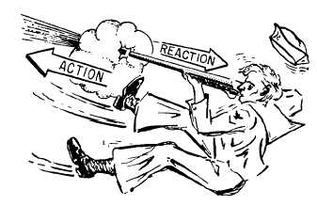
- What is Momentum, its equation, and how do you calculate with it?
- What is the Law of Conservation of
Momentum and how does it apply to collisions?

