Activity: Paper Bridge
Attempt #1 – Winging it

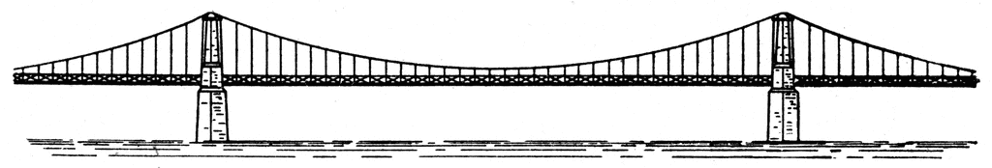
Can you build a bridge that holds a large load of pennies, using 4 sheet of paper?
A bridge must support its own weight (the dead load) as well as the weight of anything placed on it, like the pennies (the live load). Your paper bridge must span 20 centimeters (about 8 in.). The sides of your bridge will rest on two books and cannot be taped or attached to the books or the table.
What You Will Need
• plain copier paper, only 4 pieces may be used in your final design
• ruler
• 2 books or blocks
• at least 100 pennies or other small weights
• scissors
Procedure
- Mr. Green will assign you to a group of 3
- Send someone to get your supplies
- Proceed in any manner your group sees fit but you must have a bridge by the end of the day – no more construction time will be given

