Activity: Paper Bridge
Attempt #2 – Engineering Design Process

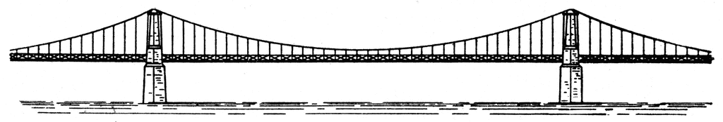
Can you build a bridge that holds a large load of pennies, using 3 sheet of paper?
A bridge must support its own weight (the dead load) as well as the weight of anything placed on it, like the pennies (the live load). Your paper bridge must span 25 centimeters (about 8 in.). The sides of your bridge will rest on two books and cannot be taped or attached to the books or the table.
What You Will Need
• plain copier paper, only 4 pieces may be used in your final design
• ruler
• 2 books or blocks
• at least 100 pennies or other small weights
• scissors
Procedure
- You will work with the same group as before, so locate them and find a spot to work.
- Send someone to get your supplies
- You will follow the engineering design process that we have learned to redesign your bridge. Listed are all of the sections that must be included in your engineers notebook. ALL STUDENTS WILL TURN IN THEIR OWN FOR GRADING!!

Sections to be included in your notebook | What is required | Check here when completed
Title Page | - Title  - Table of contents
Design Brief | - Description of project  - Criteria/constraints  - EX: must span 20 cm  - Made of copier paper  - No glue or tape  - etc
Generate concepts | - Research online  - Record sources  - Brainstorm and Sketch  - Annotated sketches  - Label sketches  - Can be parts or whole  - Must have multiple ideas  - Decision matrix/pros cons
Develop solution | - Test multiple ideas  - Create a table to show how each performed  - Select a design
Construct Prototype | - Full annotated sketch with scale  - Close ups of specific/unique design features
Test Prototype | - Call over Mr. Green for a final test  - Analyze what worked and what didn’t and create an entry to communicate this

Paper Bridge Rubric

Section | Criteria | Points
Legal Documentation | - Every page includes consistent page number that is referenced in the table of contents  - Every page is signed by author and a witness  - Every page is dated | /10
Neatness | - Notebook is neat and legible  - Sketches show signs of effort and use of ruler  - Writing does not cross lines | /10
Title page/Table of contents/Design brief | - All items are included and complete | /10
Research and generate concepts | - Evidence of multiple ideas  - Evidence of research and analysis of ideas | /20
Develop Solution | - Includes comparison table for each design and mass held  - Technical sketch of final design | /10
Post Test Analysis | - One entry analyzing what worked with the design and what failed on the bridge, including ideas for fixing the problems | /10
Mass Held | TBD | /10
Total Score |  | /80

