**Physical Science Exam Review**

**Semester 1**

**Unit 1 – Scientific Method, Experimental Design, and Variables**

1. What are the steps of the scientific method, in order? (remember that “Make an observation” comes first!
2. If you were running an experiment to determine the what amount of water would produce the largest tomatoes, identify the following variables:
   1. Independent (only 1):
   2. Dependent (only 1):
   3. Control (list at least 3):
3. Scientists often use models to help them run experiments (such as a small scale rocket, instead of a full size, in order to save costs). What are the 3 types of models and give an example of each.
4. List the sections of a scientific study (make sure you know what each is for!)

**Unit 2 - Numbers and Measurement in Science**

1. Identify the number of sig figs in each of the following:
   1. 7246
   2. 7020
   3. 1.02
   4. 2.050
   5. .000208
2. Convert the following to scientific notation
   1. 280,000
   2. 87,025,000
   3. .000205
3. Convert the following
   1. 128cm into m
   2. 120,000 mL into kL
   3. 1.89 ks into cs
4. Perform the following calculation and round your answer to the proper sig figs
   1. (2.80)(12,034)/(.0078)
5. Which SI unit is used to measure the following?
   1. Distances
   2. Time
   3. Volume of a liquid
   4. Mass
6. Which type of graph is used for the following
   1. Change over time
   2. Comparing items
   3. Parts of a whole
7. What are the following measurements, with units, to the proper precision?

* 1. 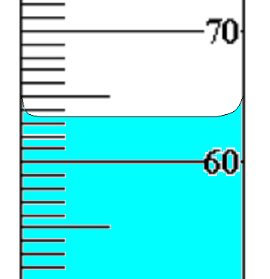

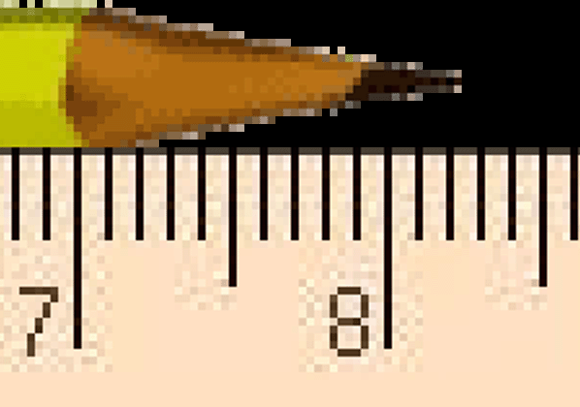

1. Using dimensional analysis convert 3.8 days into seconds.

**Unit 3 – Motion, Distance vs Displacement, Velocity and Acceleration… with graphs!**

1. What is the velocity of a bowling ball that has travelled 28.2 m in 15.2 s?
2. What is the distance a bullet travels if it has a velocity of 1400 m/s for 3.2 s?
3. What is the difference between distance and displacement?
4. A train travels East at 23.1 m/s and you run to the front of the train at 2.8 m/s, what is your resultant velocity?
5. Which line or lines show an increase in velocity?



1. Which portion of the line below shows zero acceleration?



1. What are the units for the following:
   1. Velocity
   2. Acceleration
2. Show the equation for acceleration solved for all 4 variables.
3. Calculate the acceleration of a car the starts from rest and accelerates to 12.5m/s in 3.89 s.

**Unit 4 – Newton’s Laws, Force Diagrams, Gravity, and Terminal Velocity**

1. What is terminal velocity and how do you know when a falling object has reached it?
2. An object maintains its motion unless acted upon by a Net Force is what law?
3. Using the formula for Force, calculate the acceleration of a box that has 23 N of force acting on it and has a mass of 5.0 kg.
4. Using the formula for force, determine the force acting on a 3400 kg truck that accelerates at 2.56 m/s^2.
5. Draw a force diagram of a ball that is rolling across the floor that is no longer being pushed.
6. What is the Net Forces on the following objects?

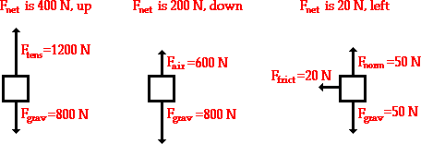

1. The force of friction always _____________ Motion.
2. Determine the missing forces in the following diagram

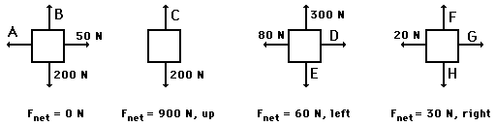

1. As two objects are moved closer together, the force of gravity between them ____________.
2. How much does a 123.6 kg man weigh on earth? (What is the acceleration due to gravity?)
3. Trying to slide a refrigerator across the floor is difficult because the force of friction is great. If you put the refrigerator on a cart with wheels the friction is reduced because you changed the type of friction from _______________ friction to _______________ friction.
4. What are the 4 fundamental forces in nature?
5. Objects are always harder to get moving than to keep in motion. This is because when the object is at rest and you push it has _____________ friction, but when it starts moving it has _______________ friction.
6. True or false: Net force is always in the direction of motion.
7. What is the momentum of a bowling ball that has a mass of 5.2 kg and a velocity of 4.3 m/s?